

Example 1 (Comparison of Overexpose and Underexpose)

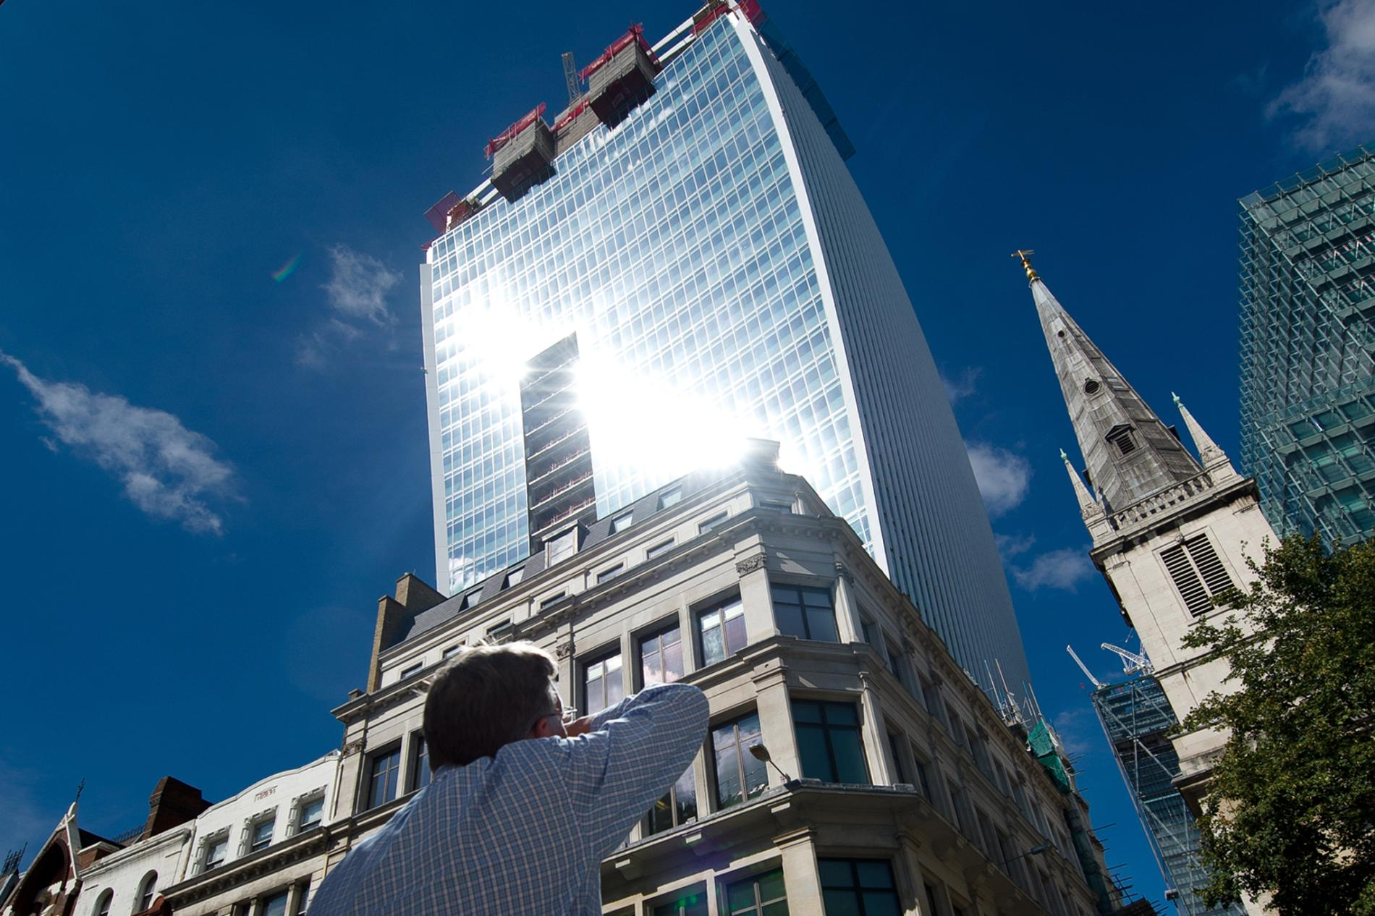

Example 2 (Reflection during broad sunlight)

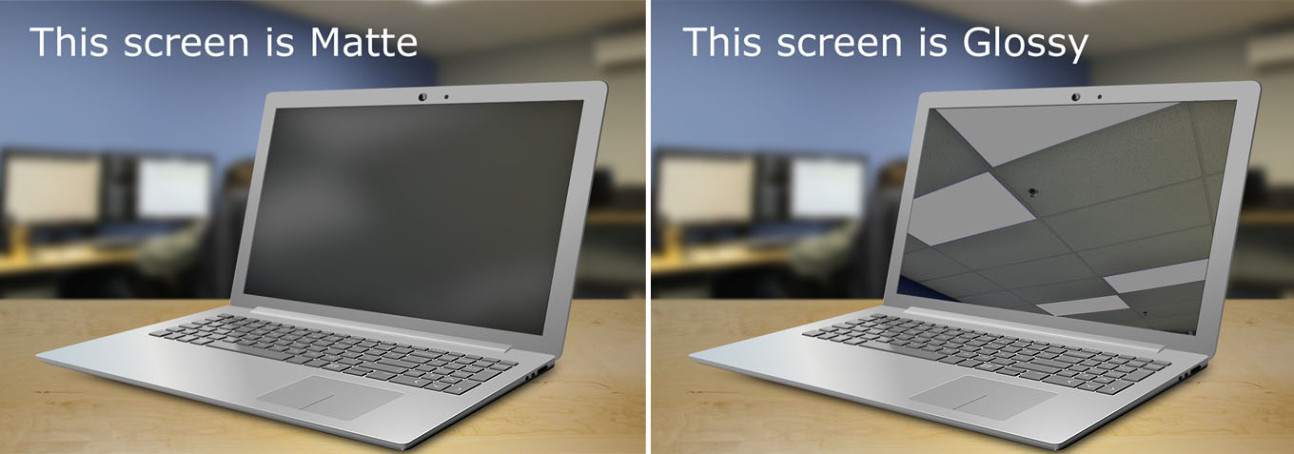

Example 3 (Comparison between Matte and Glossy)

One of the potential design problems that might be faced is that the system may be unresponsive to user inputs (hand gestures). There are two situations where this will likely happen. First, when the sun is too bright, the images received by the camera will be overexposed and the algorithm will find it difficult to identify the shape of the hand because the colour of human hands is very close to the background in the context of overexpose. Second, at night there is no external face light to light up the subject, making it even harder for the algorithm to recognize the hand gestures. Consequently, the algorithm will need a significant amount of time to do calculation and this results in the system to be very unresponsive and making it inefficient, providing a bad user experience.

Moreover, another potential design problem is that the LED display might not be easily visible under broad daylight. This is largely due to the reflection between the glass of the display and the sunlight. From the perspective of usability, this doesn’t seem to satisfy the users since it causes a very bright reflection and users will close their eyes or look away to avoid it. Hence, the purpose of this installation is not met since passer-by will not be attracted and customers will not browse the daily promotion groceries. Other than the issue with reflection, the LED display itself might not be bright enough, most consumer TVs are maxed out at 200-300 nits whereas for a display to be classified as “sunlight-readable”, it needs to be at least 1000 nits.

One possible solution to the reflection issue is to choose a matte display over glossy display. Although glossy displays produce vivid images due to their wide color range and high contrast, it comes with a cost, it reflects more light due to the fact that they are made using reflective glass. On the other hand, although matte screens do not produce as good quality images as glossy displays, they have an anti-glare coating applied to them, so they are much better at preventing reflections. In this case, the display does not need to produce very high quality images but more importantly it must be usable by the customers. Therefore, minimizing the amount of reflections is crucial.